How to Add a Certificate to a CloudFront Trust Store
Oct 23, 2026 · @Kunal Shrivastava
Trust store certificates are managed in Git: you add the CA certificate to the PEM bundle in the repo, and the pipeline validates it, compares it with S3 and applies it. Developers: use Section 1. New to Git or the pipeline: read Section 2.

Section 1 — Quick steps (developers)
Append the CA certificate to the environment's PEM bundle on a branch, get the PR approved by two people and merged, run the trust store pipeline from main (a dry run first, then apply = yes), and close the CR.
Request details (fill per request)
Item | Value
Environment | prod, test or ppe
Account | <network-services-env-account>
Trust store | <trust-store-name> (ID <trust-store-id>)
Bundle in repo | <truststore-folder>/<env>/<bundle-name>.pem
Bundle in S3 | s3://<bucket>/<key>
New certificate | <CA name> · SHA-256 fingerprint <fingerprint> · expires <date>
Requested by | <requester>, ticket <ticket>
Pipeline | <truststore-workflow>, run from main
Pipeline parameters | Dry run: environment = <env> · apply = no. Then: environment = <env> · apply = yes
Expected pipeline result | Dry run: validation passes; the S3 diff shows only the new certificate. Apply: S3 upload and trust store update succeed
Verify | Trust store: number of CA certificates goes from N to N+1
Check the certificate first
openssl x509 -in new-ca.pem -noout -subject -issuer -enddate -fingerprint -sha256
openssl x509 -in new-ca.pem -noout -text | grep -E 'Public-Key|Signature Algorithm|CA:'
Accepted: X.509v3 · RSA 2048/3072/4096 or ECDSA P-256/P-384 · SHA-256/384/512 signature · not expired. Expect CA:TRUE; if it shows FALSE, confirm with the requester.
The change (end of the bundle)
# Example Client Issuing CA added 23Oct2026 CHG0012345
-----BEGIN CERTIFICATE-----
<certificate body>
-----END CERTIFICATE-----
The comment starts with # and has no - characters. No blank lines between certificates.
Steps (numbers match Section 2, which explains each one with screenshots)
Step | Do this
1 | Check the certificate (above). Note the trust store's current count N. Not already in the bundle? Carry on.
2 | Repo → Branches → New branch: <type>/<JIRA-ID>-truststore-<env> from main.
3 | Open your branch → the bundle → pencil icon → append the comment line and certificate, nothing else → Commit changes to your branch.
4 | PR to main titled <CHG-number> <account> <trust-store-name>: add <CA name> → two approvals → Merge pull request → delete the branch.
5 | Actions → <truststore-workflow> → Run workflow from main: environment = <env>, apply = no (dry run).
6 | Log: validation passes; the diff against S3 shows only your added lines.
7 | Rerun from main with apply = yes. Trust store shows N+1 certificates and today's date. Ask the requester to test.
8 | Add the PR link, both run links, the fingerprint and the new count to the CR in ServiceNow, then close it.
You need: GitHub write access, SSO <permission-set> on the environment's network services account, and an approved <CHG-number> for prod. Problems: see Troubleshooting at the end of Section 2.

Section 2 — Reference guide (non-developers)
How to check a certificate, create a branch, commit, raise a PR, run the pipeline and confirm the trust store changed and close the CR, with screenshots.

How to implement a trust store change: end to end
Each environment's trust store holds the CA certificates CloudFront uses to check client certificates. CloudFront reads the PEM bundle from S3 only when the trust store is created or updated, so uploading a file to S3 alone changes nothing. The pipeline does both: it uploads the PEM from Git to S3, then updates the trust store.
Follow these stages in order; each links to the step that explains it, with screenshots.
- Is there a stack for this, or do I need a new one? Neither. Certificates go into the environment's PEM bundle in Git, not into a CloudFormation stack. A new trust store is a separate request; contact <owner> (Where the PEM bundles live).
- Where is its code in Git? <truststore-folder>/<env>/<bundle-name>.pem. Check the certificate first, and that it isn't already in the bundle (Step 1).
- Make the change. Create a branch, append the certificate to the bundle with the pencil icon, and commit (Step 2, Step 3).
- Get it approved and merged. Raise a PR to main, and merge it after two approvals (Step 4).
- Which pipeline do I run after the merge? <truststore-workflow>, from Actions on main: first with apply = no for a dry run, then with yes (Which pipeline to run, Step 5).
- What should I see while it runs? This pipeline has no drift check or change set. Instead, validation must pass and the diff against S3 must show only your added lines (Step 6).
- Apply. Run it again from main with apply = yes (Step 7).
- Verify in AWS. The trust store shows N+1 certificates and today's date, and the requester's test passes (Step 7).
- Close the CR. Add the evidence to the CR in ServiceNow, then close it (Step 8).
Example used below: add Example Client Issuing CA to the test trust store.

Before you start
- ☐ Write access to GitHub repo plat-eng/AWS-Landing-Zone
- ☐ AWS SSO access to the environment's network services account with <permission-set>
- ☐ The certificate file (PEM) from the requester, and ticket <ticket>
- ☐ Prod only: approved change record <CHG-number>

Rules
- Never upload a PEM to S3 or edit the trust store by hand. Git is the source of truth.
- One request = one branch = one PR; one environment per pipeline run. Name branches and PRs by the IMS rules (Steps 2 and 4); delete your branch once merged, and close PRs you abandon.
- Add, don't replace. Removing a CA locks out every client it issued.
- Test first, then PPE, then prod, each after the requester confirms the last one works.
- Every PR needs two approvals. Run the pipeline from main only: dry run first, apply only after the diff is checked.

Where the PEM bundles live
Each environment has its own bundle in the repo's trust store folder; the pipeline copies it to that environment's S3 location.
[Screenshot S1] Your OU diagram with the network services prod, test and PPE accounts highlighted.
Environment | Account | Bundle in repo | S3 location | Trust store
prod | <ns-prod-account> | <truststore-folder>/prod/<bundle-name>.pem | s3://<prod-bucket>/<key> | <prod-trust-store>
test | <ns-test-account> | <truststore-folder>/test/<bundle-name>.pem | s3://<test-bucket>/<key> | <test-trust-store>
ppe | <ns-ppe-account> | <truststore-folder>/ppe/<bundle-name>.pem | s3://<ppe-bucket>/<key> | <ppe-trust-store>
[Screenshot S2] GitHub: <truststore-folder>/ expanded, showing prod, test and ppe.
↑ Back to the end-to-end summary

Which pipeline to run
Trust store changes always use <truststore-workflow>. Run it from Actions on main after the PR is merged, twice:
Run | Parameters | Expected result
1. Dry run | environment = <env> · apply = no | Green run; validation passes; the diff against S3 shows only your added certificate; nothing changes
2. Apply | environment = <env> · apply = yes | Green run; S3 upload and trust store update succeed; the trust store shows N+1 certificates
Not for trust stores: <cfn-deploy-workflow> and <direct-deploy-workflow>; both deploy CloudFormation stacks.
↑ Back to the end-to-end summary

Step 1 — Check the certificate and the current bundle
- Save the requester's file as new-ca.pem. In the AWS console open CloudShell → Actions → Upload file → new-ca.pem.
- Run the two openssl commands from Section 1 and check the output:
Check | Must be
Format | One BEGIN CERTIFICATE / END CERTIFICATE block of text
Key (Public-Key) | RSA 2048, 3072 or 4096, or ECDSA P-256 or P-384
Signature | SHA-256, SHA-384 or SHA-512
Expiry (notAfter) | In the future
CA: | TRUE (root or intermediate CA); FALSE → confirm with the requester
- In GitHub, open the environment's bundle and search (Ctrl+F) for the CA name from subject. Found → it's already trusted; stop.
- CloudFront console → Trust stores → <trust-store-name>. Note Number of CA certificates (N). It should match the number of BEGIN CERTIFICATE lines in the bundle; if not, stop.
Example: Example Client Issuing CA · RSA 2048 · SHA-256 · CA:TRUE · valid to 2031 · not in the test bundle → add it.
[Screenshot S3] CloudShell with the openssl output. Highlight: subject, notAfter, Public-Key, CA:TRUE.
[Screenshot S4] CloudFront › Trust stores › <trust-store-name>. Highlight: Number of CA certificates and Last modified.
↑ Back to the end-to-end summary

Step 2 — Create a branch
- Open plat-eng/AWS-Landing-Zone.
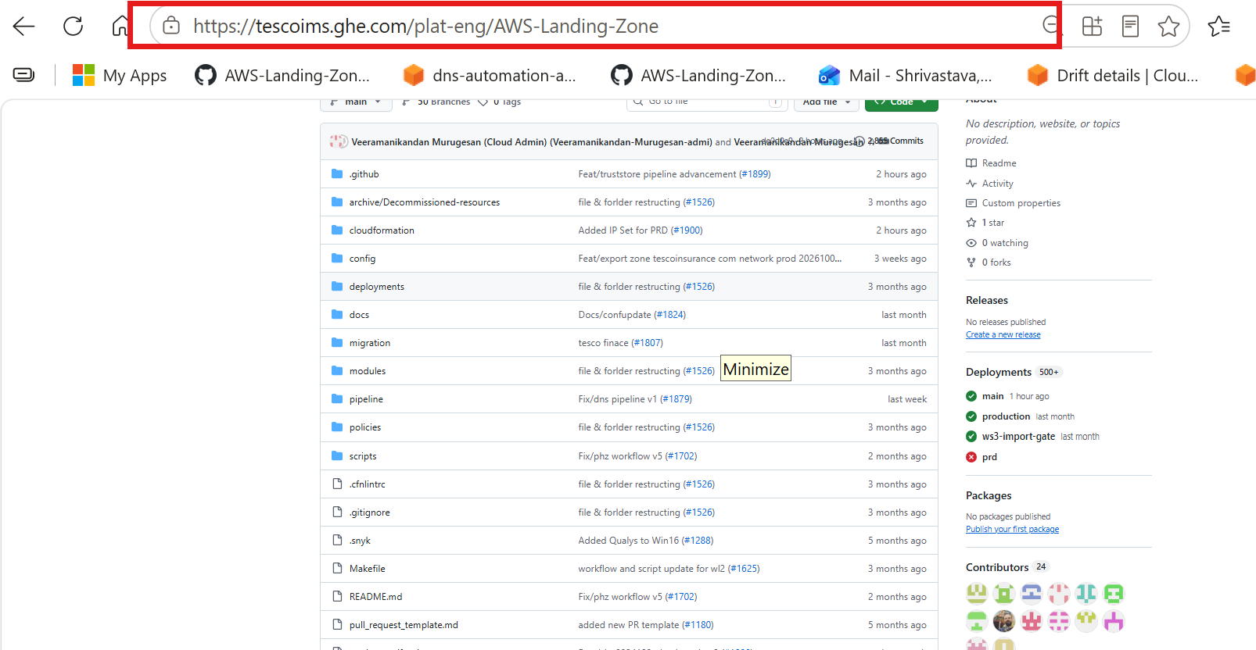
- Click Branches, next to the branch selector.
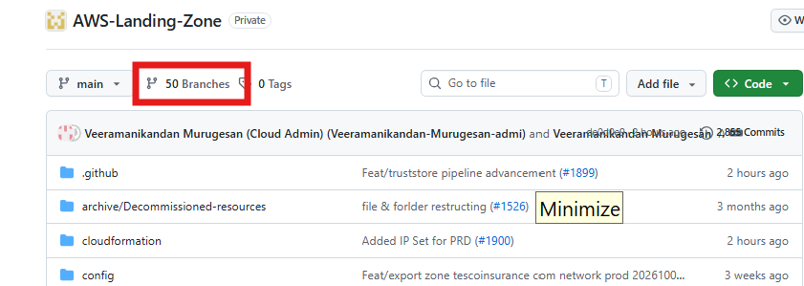
- Click New branch (top right).
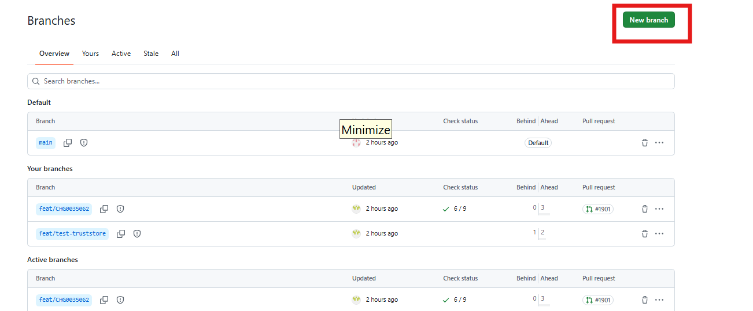
- Type the branch name <type>/<JIRA-ID>-truststore-<env>, keep Source = main, then click Create new branch.
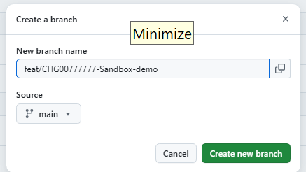
- The branch appears under Your branches. Click its name.
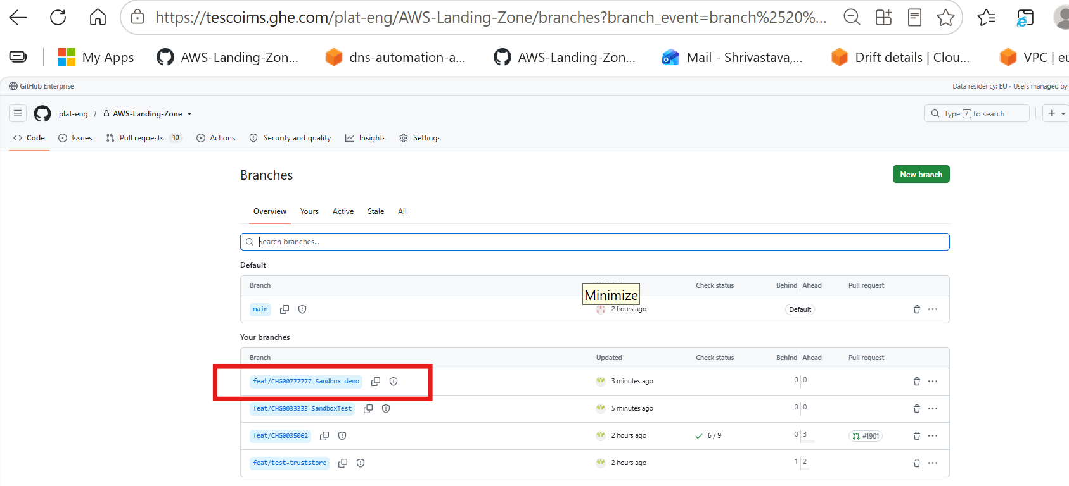
- Check the address bar ends in /tree/<branch-name>. You're now on your branch.
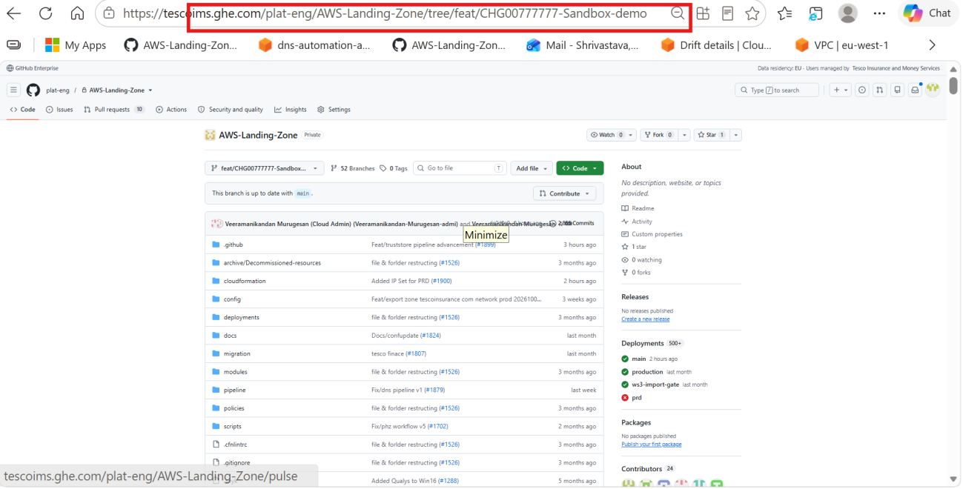
Branch name (IMS rule): <type>/<JIRA-ID>-<short-description>, lowercase, with hyphens between words. Types: feat/ new features · fix/ bug fixes · chore/ maintenance and IaC changes · docs/ documentation only · hotfix/ urgent production fixes. The screenshots show a sandbox demo branch; yours gets its own name.
↑ Back to the end-to-end summary

Step 3 — Add the certificate and commit
- On your branch (the branch selector shows its name, not main), open <truststore-folder>/<env>/<bundle-name>.pem → pencil icon (Edit this file).
- Go to the last line. Directly below it, add a comment line, then paste the certificate:
-----END CERTIFICATE----- ← last line already in the file
# Example Client Issuing CA added 23Oct2026 CHG0012345
-----BEGIN CERTIFICATE-----
<certificate body>
-----END CERTIFICATE-----
- No blank lines before, inside or after the new block. Don't touch any other line.
- Commit changes… → message <ticket>: add <CA name> to <env> trust store → keep Commit directly to the <your-branch> branch → Commit changes.
[Screenshot S6] Editor on your branch at the end of the bundle. Highlight: the comment line and the new certificate block.
[Screenshot S7] Commit changes dialog. Highlight: message and "Commit directly to the … branch". Reusable.
↑ Back to the end-to-end summary

Step 4 — Raise a PR and merge
Two people must approve the PR before it's merged.
- Pull requests → New pull request: base main ← compare your branch. Files changed must show only your added lines.
- Title, per the IMS rule: change number, account, trust store, then the change, e.g. <CHG-number> <account> <trust-store-name>: add <CA name>. In the description, give the requester, subject, SHA-256 fingerprint and expiry. Add two reviewers (<reviewer-or-team>) → Create pull request.
- After two approvals: Merge pull request → Confirm merge → Delete branch.
[Screenshot S8] New pull request › Files changed. Highlight: only added lines at the end of the bundle.
[Screenshot S9] Pull request with two approvals and the Merge pull request button. Reusable.
↑ Back to the end-to-end summary

Step 5 — Run the pipeline (dry run)
- Straight after the merge: Actions tab → <truststore-workflow> → Run workflow.
- Use workflow from: main · environment: <env> · apply: no.
- Run workflow → open the run → wait for the green tick.
[Screenshot S10] Run workflow panel filled in. Highlight: main, environment, apply = no.
↑ Back to the end-to-end summary

Step 6 — Review the dry run
Check the run log before applying anything:
Log section | Expect | Stop if
Validation | Every certificate in the bundle passes | Any error (see Troubleshooting)
Diff against S3 | Only your comment line and certificate are added | Any removed or changed line
[Screenshot S11] Dry-run log. Highlight: validation result and the diff showing one added certificate.
Not as expected → fix the PEM through a new PR (Steps 2–4), then rerun Step 5.
↑ Back to the end-to-end summary

Step 7 — Apply and verify
- Run the workflow again from main: same environment, apply: yes.
- In the log, check the S3 upload and the trust store update both succeeded.
- CloudFront console → Trust stores → <trust-store-name>: Number of CA certificates = N+1, Last modified = today.
- Ask the requester to test with a client certificate issued by the new CA:
curl -sv --cert client.pem --key client.key https://<mtls-domain>/<path> -o /dev/null
# expected: TLS handshake completes and the API's normal response (e.g. HTTP 200)
Next environment: repeat from Step 2 once the requester confirms.
[Screenshot S12] Apply run log. Highlight: S3 upload and trust store update.
[Screenshot S13] CloudFront › Trust stores › <trust-store-name>. Highlight: Number of CA certificates = N+1 and Last modified.
↑ Back to the end-to-end summary

Step 8 — Close the CR
Close the CR only after the trust store shows N+1 certificates and the requester confirms the test.
- Open the CR <CHG-number> in ServiceNow.
- In Work notes, add the merged PR link, both run links (dry run and apply), the certificate's subject and SHA-256 fingerprint, the count before and after, and the requester's confirmation. Evidence missing? Say so in the notes; don't leave it out.
- Set Close code to match what happened (Successful only if every check passed) and write Close notes.
- Move the CR to <cr-close-state>, as your change process requires. One CR covering several environments? Close it after the last one.
Example close notes: Added Example Client Issuing CA (SHA-256 <fingerprint>) to <trust-store-name> in test. CA count N → N+1; requester's client test passed.
[Screenshot S14] ServiceNow CR with work notes and close details filled in. Highlight: State, Close code, Close notes. Reusable across runbooks.
↑ Back to the end-to-end summary

Troubleshooting
Find the symptom, apply the fix, then rerun from the step shown.
Symptom | Likely cause | Fix
Validation fails on a comment line | Comment contains - or doesn't start with # | Fix it through a new PR (Steps 2–4) using letters, digits and spaces only; rerun Step 5.
Validation fails near the new certificate | Blank line, missing BEGIN/END line, or stray spaces from copy-paste | Re-paste the certificate exactly through a new PR; no blank lines.
Unsupported key or signature | e.g. RSA 1024, SHA-1, ECDSA P-521 | Ask the requester for a CA certificate that meets the rules in Step 1.
Diff shows lines you didn't change | S3 was edited by hand, or another merged bundle change hasn't been applied yet | Stop. <owner> reconciles S3 with Git before anyone applies.
Count didn't change after apply | The trust store wasn't updated (it reads S3 only on create or update) | Check the apply log; rerun with apply = yes or contact <owner>.
Client still rejected | Client certificate wasn't issued by the new CA, the chain needs an intermediate, or the client certificate expired | Compare openssl x509 -in client.pem -noout -issuer with the new CA's subject; ask for the intermediate.
Merge pull request is disabled (merging is blocked) | Fewer than two approvals, or checks still running | Wait for both approvals and green checks.
Pipeline fails at the AWS credentials step | Deploy role doesn't trust the repo, or is missing in the account | Contact <owner>.

References
- Trust stores and certificate management: PEM rules, supported keys and signatures, read-once behaviour, the details page — Amazon CloudFront

Review notes (delete before publishing)
Confirm these, fill the placeholders, then capture S3, S4 and S6–S14 during one real request in test. S7 and S9 can be reused across runbooks; the Step 2 branch screenshots are already in place.
- ☐ Workflow: name and exact inputs (<truststore-workflow>, environment, apply).
- ☐ Paths: trust store folder name, bundle file names, and the S3 bucket and key per environment.
- ☐ Dry-run output: does it print the certificate count and fingerprints? Worth adding if not.
- ☐ Environment order: test → PPE → prod, and who confirms each.
- ☐ Change record: needed for prod only, or every environment?
- ☐ Removals: a separate runbook, or a section in this one?
- ☐ Branch screenshot: it shows feat/CHG00777777-Sandbox-demo, but the IMS rule asks for a Jira ID and lowercase. Keep it, or retake it with a compliant name.
- ☐ CR closure: who closes the CR, which states it moves through (fill <cr-close-state>), and whether each environment gets its own CR.
Placeholders: <truststore-folder>, <bundle-name>, buckets and keys, trust store names and IDs, accounts, <permission-set>, <truststore-workflow>, <owner>, <reviewer-or-team>.

